Create a timeline of historic inventions
  - Student guide B

Step 2
Create your timeline

Software: Microsoft® Office Excel® 2007

What to do: Select, order, and present the experiments in a timeline

Note: If you’re already an expert in creating timelines in Office Excel, you can proceed directly to creating your timeline. If you’re not familiar with using Office Excel to create timelines or you want to refresh or improve your skills, watch the video Create a timeline using Microsoft Office Excel (Windows Media video) before you begin. Step-by-step instructions will help you create professional-looking timelines. http://www.microsoft.com/education/en-us/teachers/how-to/Pages/timeline.aspx --This website contains the video and has more instructions on how to create a better timeline.
Start Office Excel with a new, blank spreadsheet open.
Type the title Timeline of Historic Inventions across the top of the spreadsheet, and format the text as you like.
Skip several rows, and then type the first date or time of your timeline. You can format the date and time now or wait until you have entered all dates and times and format them all at once.
Type a short description above the date or time cell. For example, “Thomas Edison invents the first working phonograph.”
Text can be entered sideways to mark significant events. For example, this Technology Timeline features rotated text within cells, as well as borders around the cells (Step 8), and cell fill colors (Step 10).
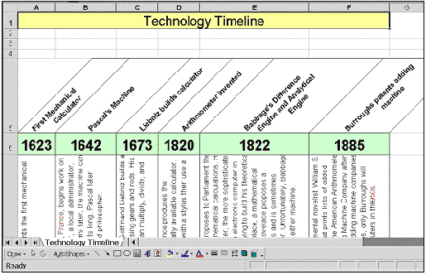
See full-sized image
To format the description so it is turned sideways, on the Format menu, click Cells. In the Format Cells box, click the Alignment tab (see picture). Select the orientation for the text by clicking the picture sample or by typing a number in the Degrees box. Change the text alignment (horizontal or vertical), and then click OK.
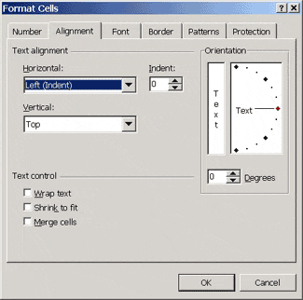
Tip: You might want to format a group of cells (for example, all cells that should be rotated) at the same time. First select the group of cells, click Cells on the Format menu, apply the formatting you want, and then click OK. All selected cells will now be formatted the same. Type your text in those cells and press ENTER. The cells will be rotated automatically because you preformatted them.
Finish typing the short description text above each cell in your timeline.
Type the information you gathered about the invention (name of inventor, how it affected people’s lives, and any other information) below the date cell. You might want to enter this text sideways, too, as described in Step 5.
Format the cells as needed (font, size, color, and so on). If you want to add a box around a cell or group of cells, click Borders on the Formatting toolbar.
You can change the width of your columns. Position the mouse pointer on the lines that separate any two column headings (between the column letters), and then drag the line right or left to change the column's width.
You can designate periods of time (maybe each century is a different color or every other invention is a different shade of grey to differentiate each invention) by using fill colors to color groups of cells. To fill in cells with color:
- Select the cells you want to color.
- Click Fill Color (paint bucket) on the Drawing toolbar. (If the Drawing toolbar is not visible, click View, click Toolbars, and then click Drawing.)
If you want to add pictures to your timeline, select them from the clip art selection or another source (such as the Internet, a CD, a scanner, or a digital camera). Resize and move them as needed.
If you want to enter text inside pictures or drawings:
- Click the drawing or picture you want to add text to.
- Click the Insert tab.
- Click Text Box.
- Click inside the picture. A text box appears.
- Enter your text and save it.
Save your timeline frequently so you do not lose your information.

