Lessons 1-2 Practice Quiz

Label the following parts of a spreadsheet:
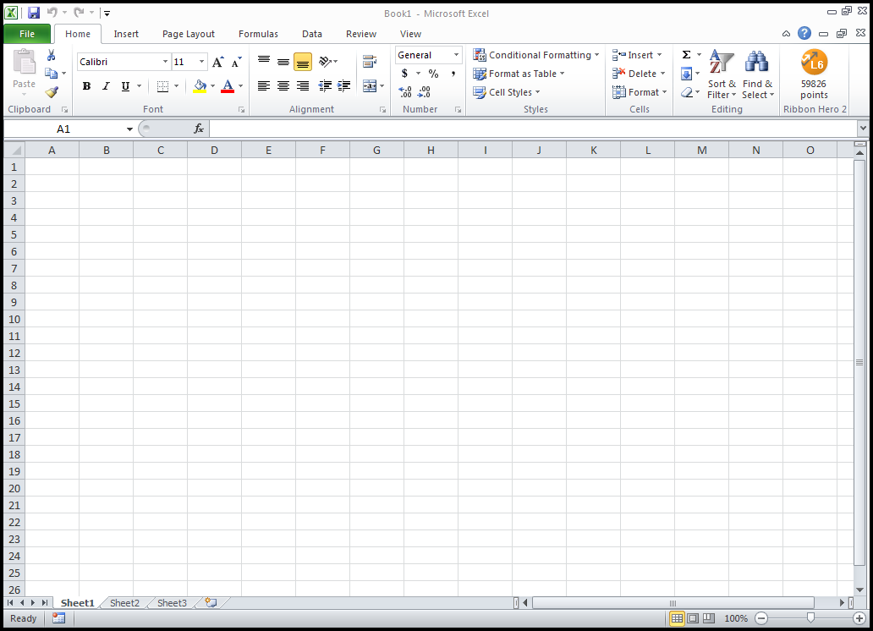

Name the tab and group where each button can be found:
Tab:
Group:

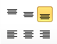
Tab:
Group:
Tab:
Group:
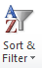
Tab:
Group:
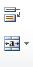
Tab:
Group:
Tab:
Group:

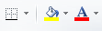
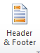
Tab:
Group:
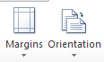
Tab:
Group:
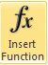
Tab:
Group:

Describe the steps to change a column to currency:
_________________________________________________________________________________ _________________________________________________________________________________
In your own words, explain absolute value:
_________________________________________________________________________________ _________________________________________________________________________________
What is the difference between a formula and a function?
_________________________________________________________________________________ _________________________________________________________________________________

Key in the following spreadsheet in a Microsoft Excel Spreadsheet::

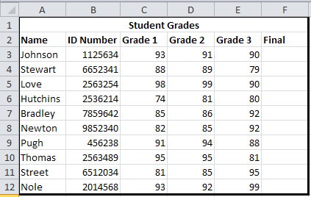

Apply the following changes:
- Format the student names as bold and itialics
- Format Columns C, D, E and F as percent with 2 decimal places
- Enter a function in column F that will average the grades from columns C, D and E
- In cell A14, Enter the word Average
- In cell C14, Enter a function that will average the grades from column C
- Copy the function to cells D14, E14, and F14
- In Cell A15, enter the word Highest
- In cell C15, enter a function that will find the highest grade from column C
- Copy the function to cells D15, E15, and F15
- In cell A16, enter the word Lowest
- In cell C16, enter a function that will find the lowest grade in column C
- Copy the function to cells D16, E16, and F16
- Add an accounting border (single line above, double line below) to cells C14, D14, E14, and F14
- Change the outside border of the entire table to a double line border
- Add a header with your name, today’s date (Feb. 12) and the assignment title (Functions)
- Save the Excel document as Functions to your H drive.

