- Highlight Cells B3:U20- Fill the cells with the color Dark Green (In the Font Group)
Create a football field
- Change the width of Column A to 14 (In the Cells Group, Format, Column Width)
- Change the width of Column V to 14
- Merge and Center cells A3-A20 (In the Alignment Group)
- Merge and Center cells V3-V20
- Highlight Columns B through U and Change the column width to 6.43
- Change the row height of Rows 3 & 20 to 18.75
- Change the row height of Rows 5 through 18 to 21
- Apply a Thick Box Border In Black to the Merged Rows in Column A & V
- Insert 4 Capital I’s in the Cell B3- Change font to Arial Narrow, Bold, Size 11, White
- Center align and Top Align the I’s
2 spaces between each line
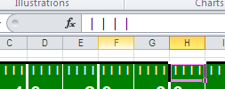

- Use the Copy & Paste buttons to apply it to Cells B3:U3, B7:U7, B16:U16, B20-U20 (Bottom Align B20-U20)
- In White, Bold, Arial 20 Font
- Type -1 in Cell C4.
- Type 0 in Cell D4. Left Align the Number. Copy to Cells F4, H4, J4, L4, P4, R4, & T4
- Type -2 in Cell E4.
TIP: USE THE FORMAT PAINTER TO APPLY FORMATTING TO ALL THE OTHER NUMBERS EXCEPT 0. FOR 0 COPY AND PASTE!!
- Type -3 in Cell G4
- Type in -4 in Cell I4
- Type in 5 in Cell K4
- Type in 4 in Cell M4
- Type in 3 in Cell 04
- Type in 2 in Cell Q4
- Type in 1 in Cell S4
- Right Align -1, -2,-3, -4, 5, 4, 3, 2, 1
- Copy C4:T4, Paste to C19:T19
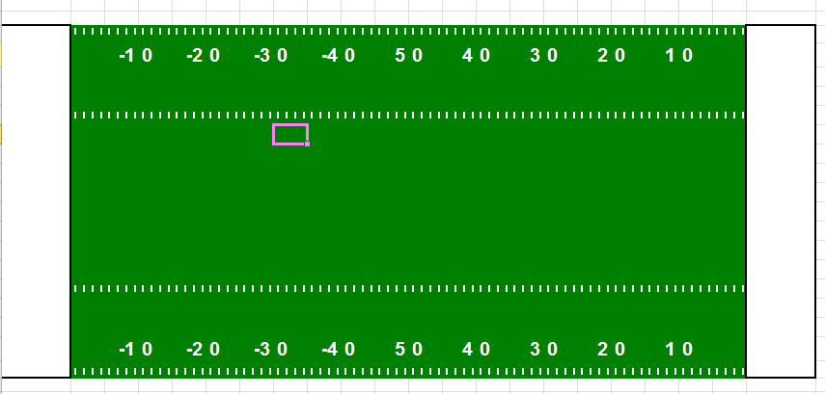
**YOUR EXCEL DOCUMENT SHOULD LOOK LIKE THIS

Select the border down arrow. (In the font group)
Change the line style to a thick line (last line) and the line color to white
Click the borders down arrow again and select draw Border if it is not already selected so you can draw the borders.
Draw a thick white line between the numbers as shown in the picture below.
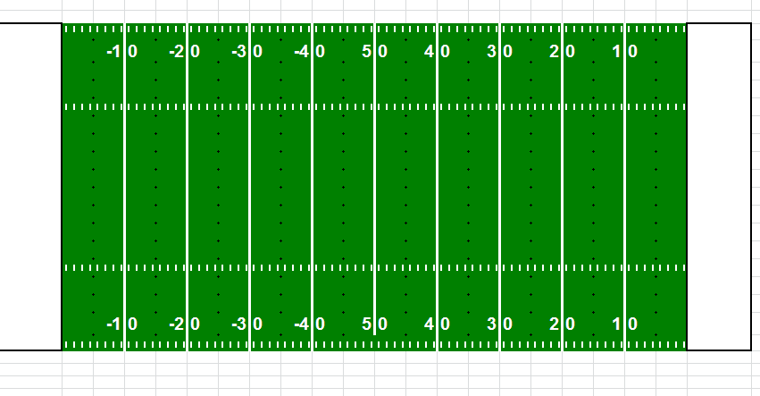
Next go back to the line style and change it to thin white line and draw the 5, 15, 25, etc. lines.
Highlight the entire football field and add a thick black border around the field and End Zones. See picture below for help!
Change the End Zones to your favorite team (Rotate text up on one side and rotate text down on the other).
Add a logo and other features if you would like. Copy an image from Google and paste into the sheet.
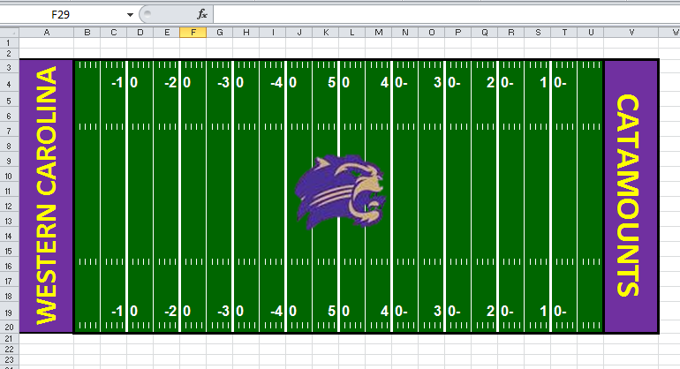
My finished field!

